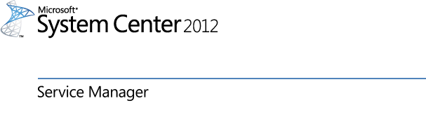

Migration Guide for System Center Virtual Machine Manager Self-service Portal 2.0 SP 1
Microsoft Corporation
Published: May 7, 2012
Applies To
System Center Cloud Services Process Pack
Feedback
Send suggestions and comments about this document to cloudservicesfdbk@microsoft.com.

This document is provided "as-is". Information and views expressed in this document, including URL and other Internet Web site references, may change without notice.
Some examples depicted herein are provided for illustration only and are fictitious. No real association or connection is intended or should be inferred.
This document does not provide you with any legal rights to any intellectual property in any Microsoft product. You may copy and use this document for your internal, reference purposes. You may modify this document for your internal, reference purposes.
© 2012 Microsoft Corporation. All rights reserved.
Microsoft, ActiveX, Active Directory, Bing, Internet Explorer, MSDN, SharePoint, Silverlight, SQL Server, Visual Basic, Visual Studio, Windows, Windows Intune, Windows PowerShell, Windows Server, and Windows Vista are trademarks of the Microsoft group of companies. All other trademarks are property of their respective owners.
Revision History

Release Date | Changes
May 7, 2012 | RTM release of this guide.

Contents
Overview 1
Data Hierarchy 1
Data that is Migrated 2
Data that not Migrated 2
Prerequisites 2
Permissions 2
Preparing to Migrate 2
Plan VMM User Roles 2
Prepare the Destination Server 3
Prepare the Virtual Machine Manager Server 3
Install the Migration Tool 3
Running the Migration Tool 4
Migration Wizard 4
Post-Migration Tasks 17
Verify Migration 17
Associate Virtual Machines with Cost Centers 17

Overview
The goal of migration tool is to support IT service management in migrating System Center Virtual Machine Manager 2008 R2 Self-Service Portal 2.0 SP1 data to System Center Service Manager 2012.
This document provides guidance for migrating the business unit, service and VMM data from the System Center Virtual Machine Manager 2008 R2 Self-Service Portal 2.0 SP1 to the System Center Service Manager 2012 database.
For more information on System Center Virtual Machine Manager 2008 R2 Self-Service Portal 2.0 SP1, see http://technet.microsoft.com/en-us/library/gg588342.aspx.
Warning

The Cloud Services Process Pack can be modified in Service Manager. If the process pack model (tenant, cloud resources subscription or configuration items template) is modified, then the migration tool might not work.
Warning
The migration tool can be used more than once. The migration tool will allow previously assigned virtual machines to be assigned to additional cloud resources subscriptions. If you use the migration tool more than once, make sure that you do not assign the virtual machines to the multiple cloud resources subscriptions.

Data Hierarchy
The Cloud Services Process Pack data hierarchy has fewer layers than the VMMSSP SP1 data hierarchy. As a result, all data in VMMSSP SP1 is not migrated to the process pack database.
The following figure shows an example of the data hierarchies and which data is migrated.

Figure 1. Example of data hierarchies

Data that is Migrated
The following data is migrated:
- Business Unit
- Service
- Virtual Machines
- Business Unit Administrator
- Business Unit Users

Data that not Migrated
The following list is an example of data that is not migrated:
- Infrastructure
- Service Role
- DCIT administrators

Prerequisites

Permissions
The account used to run the migration wizard should have the following roles:
- Local Administrator on the Virtual Machine Manager Self-service Portal 2.0 database Server
- Owner of the Virtual Machine Manager Self-service Portal 2.0 database (DITSC)
- Administrator in Service Manager

Preparing to Migrate
Before you begin the migration, you must complete these tasks. You will not be able to complete migration without preparing the servers prior to running the migration wizard.

Plan VMM User Roles
Before migrating you will need to create a plan on how your configuration will handle user roles. With that information, you will need to create self-service user roles in VMM before running the Migration Wizard.

Prepare the Destination Server
- Install and configure System Center 2012 – Service Manager.
- Install and configure the System Center Cloud Services Process Pack.
- Create a Tenant Administrator user role and a Cloud Resources Subscription user role and configure user roles in the general properties.
- Create the cost centers that will be used when migrating the Business Unit.
For procedures on how to prepare the destination server, see the Cloud Services Process Pack Administration Guide at http://go.microsoft.com/fwlink/?LinkId=251874.

Prepare the Virtual Machine Manager Server
- Upgrade virtual machines and templates from Virtual Machine Manager 2008 R2 to Virtual Machine Manager 2012.
- Create clouds in Virtual Machine Manager and associate the Virtual Machines to be migrated with the appropriate cloud.
- Create the Virtual Machine Manager self-service user role for the cloud. Then, get the Virtual Machine Manager self-service user role guid that is created for the cloud by running Virtual Machine Manager Power Shell Commandlet get-scuserrole -name "<VMM User role name>". This will be used for the cloud services subscription that is created during migration.

- Important
After the destination and virtual machine manager servers have been prepared, you must synchronize the System Center 2012 – Virtual Machine Manager (VMM) connector with System Center 2012 – Service Manager.

Install the Migration Tool
The System Center Cloud Services Process Pack migration tool should be run from the server with the VMMSSP2.0 engine component.
- Copy VMMSSP2SP1Migration.exe from the zip file to the VMMSS2.0 engine machine.

Running the Migration Tool
Use this procedure to run the System Center Cloud Services Process Pack migration tool.
- Right-click VMMSSP2SP1Migration.exe and select Run As Administrator.
- Click Unzip to extract the files and click Ok
- Go to the extracted location
- Open the folder VMMSSP2SP1Migration and run VMMSSP2SP1Migration.exe as an administrator. This will launch the Cloud Services Migration Wizard.

Migration Wizard
Use this procedure to complete the Cloud Services Migration Wizard.

- On the Before You Begin page, click Next.
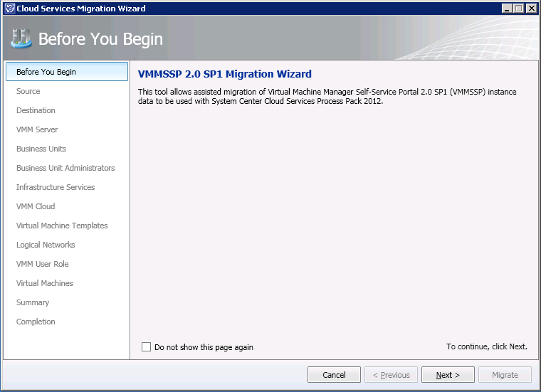
Figure 1. Cloud Services Migration Wizard

- On the Source page type the Virtual Machine Manager 2008 R2 Self-Service Portal 2.0 SP1 Database Server name and then click Get instances.
- Select the instance that has the Virtual Machine Manager 2008 R2 Self-Service Portal 2.0 SP1 database from the SQL Server instance drop-down box.
- Select the appropriate authentication method and then click Next.

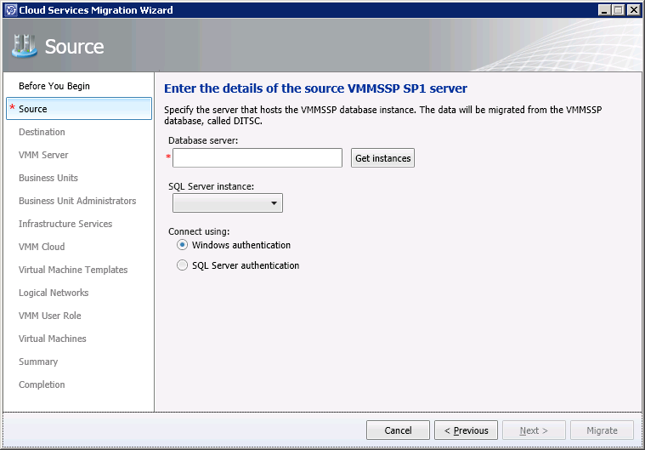
Figure 2. Source
- On the Destination page, type name of the Service Manager 2012 server and click Next.
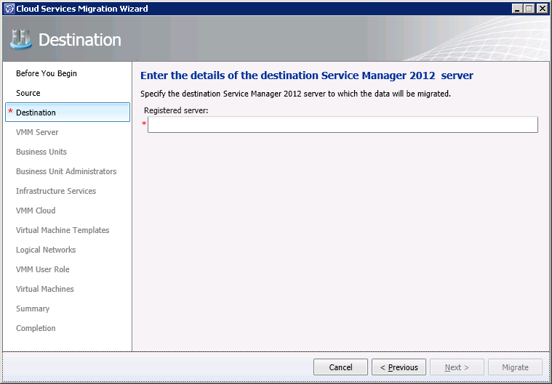
Figure 3. Destination

- The VMM Server page displays the names of the Source VMM server and the Destination VMM server. If the destination field is empty, either the VMM server has not been upgraded to Virtual Machine Manager 2012 or the Virtual Machine Manager and Operations Manager connector has not been created and synchronized on Service Manager. Review the information and click Next.
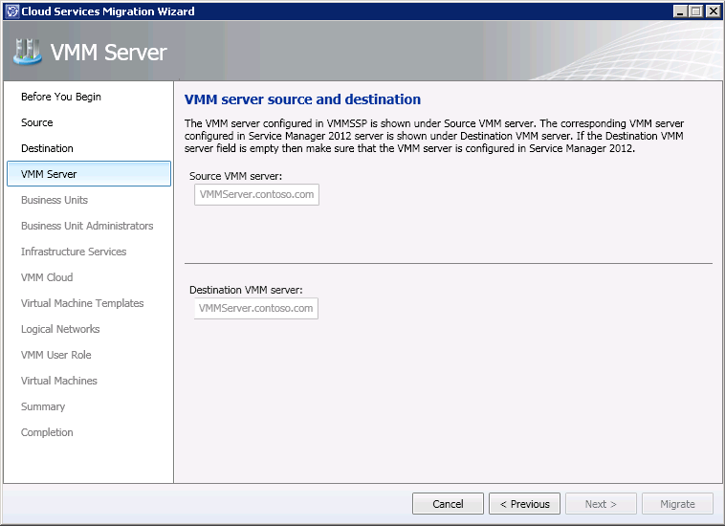
Figure 4. VMM Server Source and Destination

- The Business Units page lists all of the business units that are available for migration. The first time that you run the migration tool you will need to create a new tenant. Then, on subsequent migrations you should migrate the additional business unit services into the existing tenant.

To migrate a business unit into a new tenant
- Select a business unit from the Source Business Units list.
- Select Create a new tenant and select a cost center from the Cost center drop-down list.
- Click Next.

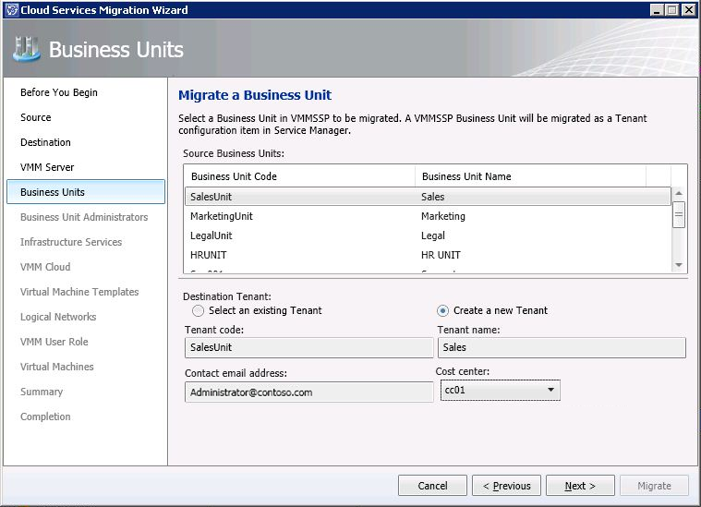
Figure 5. Migrate a Business Unit

To migrate a business unit into an existing tenant
- Select a business unit from the Source Business Units list.
- Click Select an existing tenant and then select the name of the existing tenant from the Existing Tenants drop-down list.
- Click Next.

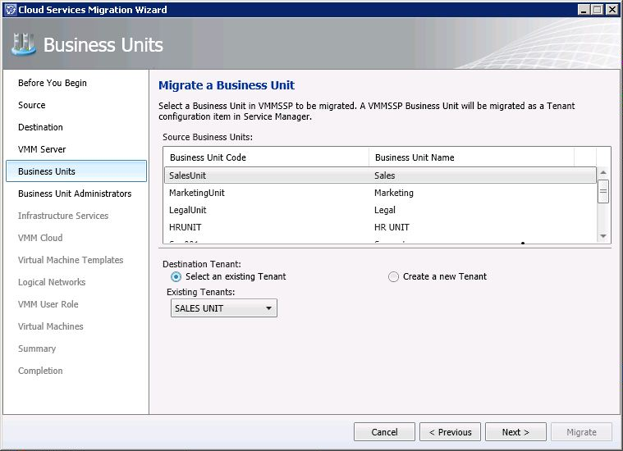
Figure 6. Migrate a Business Unit

- On the Business Unit Administrators page, select the users who will be administrators on the migrated tenant. By default all users are selected. To edit the list, uncheck the box next to the administrator name.
Important
Selecting users is an optional step in the migration wizard. However, if users are not selected during migration, then users will need to be added from the Service Manager console.

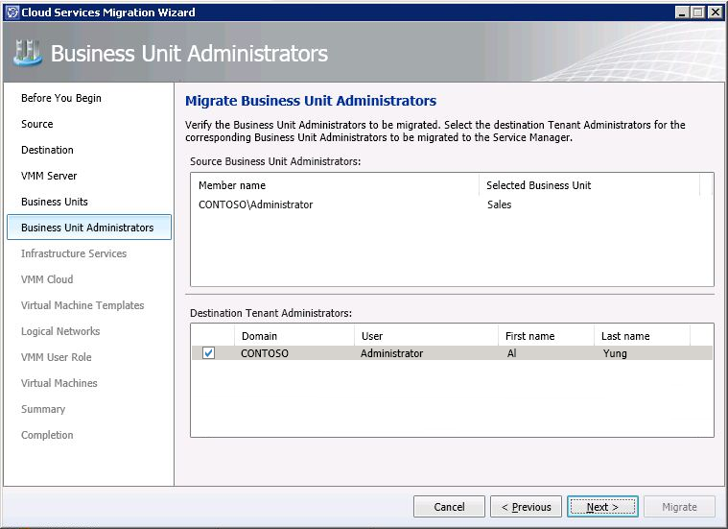

Figure 7. Migrate Business Unit Administrators

- The Infrastructure Services page lists all of the services that are available for migration. It is important to note, only one service can be migrated each time that the migration wizard is used. If you have multiple services for each business unit, then you will need to run the migration wizard once for each service.
Warning
Previously migrated services will appear in the Source Infrastructure Service list. Be careful that you do not migrate the services more than once. If you migrate more than once you will create duplicate entries in Service Manager.

To migrate a service
- Select a service from the Source Infrastructure Service list.
- The Cloud Resources Subscription name, Storage quota, and Memory quota fields will be automatically populated. You can leave these fields as they are, or you can change the values. To change the values, type new values in the fields.
- Type the number of virtual machines and Virtual CPUs that you want to assign to the cloud resources subscription.
- Click Next.

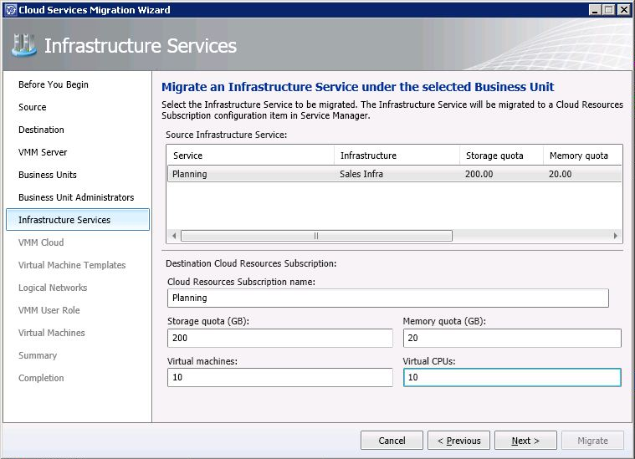
Figure 8. Infrastructure Services

- The VMM Cloud page displays details about source provisioned networks and library shares. Click Source, review the details, select the appropriate destination VMM cloud and click Next.
The Destination VMM cloud drop-down box is populated when the System Center 2012 – Operations Manager CI connector is synchronized with System Center 2012 – Service Manager.

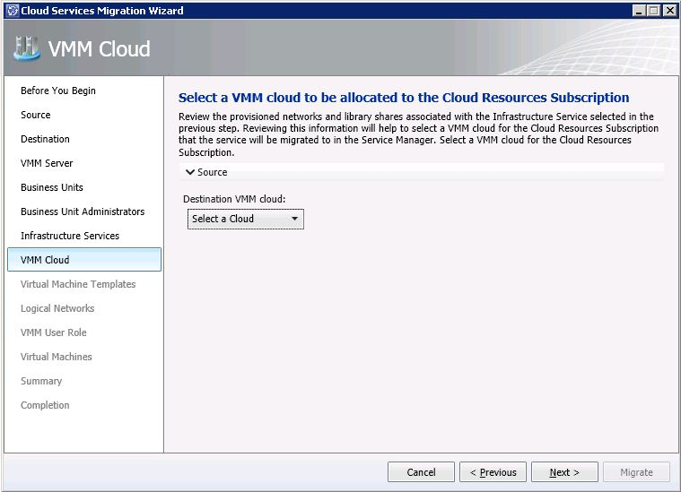
Click Source to view the details.
Figure 9. VMM Cloud

- The Virtual Machine Templates page displays all of the templates that are configured for the service on the Source Provisioned VM Templates list. To add templates, select the templates from the Destination VM Templates list, and then click Next.
Important
Selecting templates is an optional step in the migration wizard. However, if templates are not selected during migration, then templates will need to be added from the Service Manager console before the cloud resources subscription can be used.

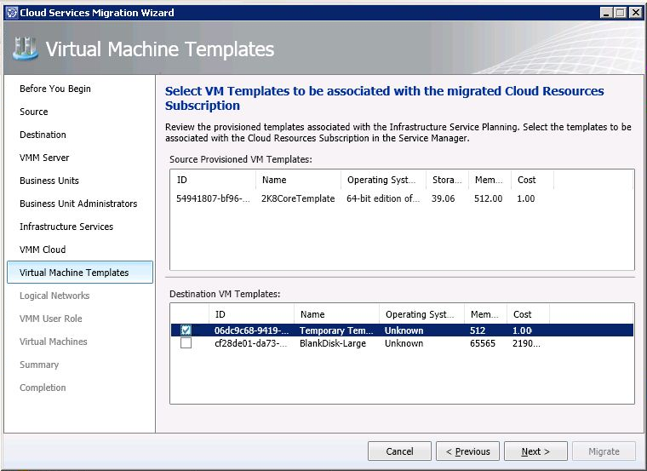
Figure 10. Virtual Machine Templates

- The Logical Networks page displays all of the networks that are configured for the service on the Source Provisioned Networks list. To add networks, select the networks from the Destination Logical Networks list, and then click Next.

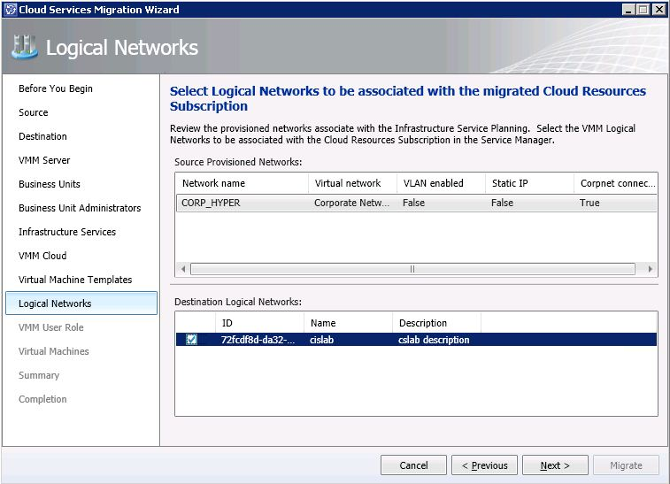
Figure 11. Logical Networks

- The VMM User Role page displays the users that are assigned to the service that was selected for migration on the Source Infrastructure Service Users list. Type the VMM User Role Name and VMM User Role GUID of the user role that was created for the cloud. To edit the list, uncheck the box next to the Destination Cloud Resources Subscription user name.
To get the Virtual Machine Manager self-service user role GUID that is created for the cloud by running Virtual Machine Manager, use the Power Shell Commandlet get-scuserrole -name "<VMM User role name>".

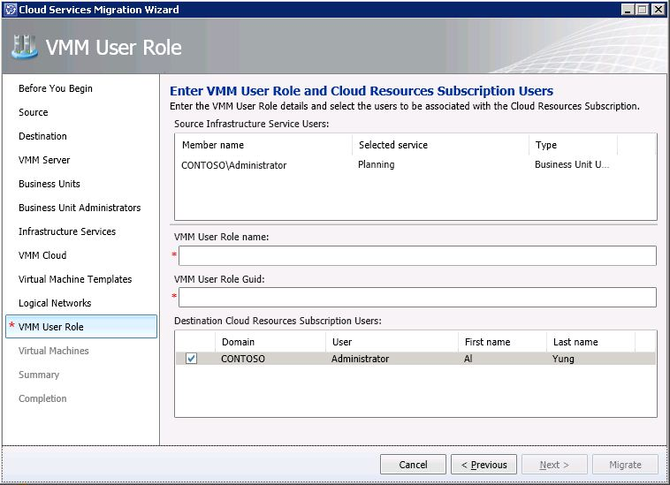
Figure 12. VMM User Role

- On the Virtual Machines page, by default all of the destination virtual machines will be displayed for the source. To select the Destination Virtual Machine, check the box next to the virtual machine name. Multiple machines can be selected.

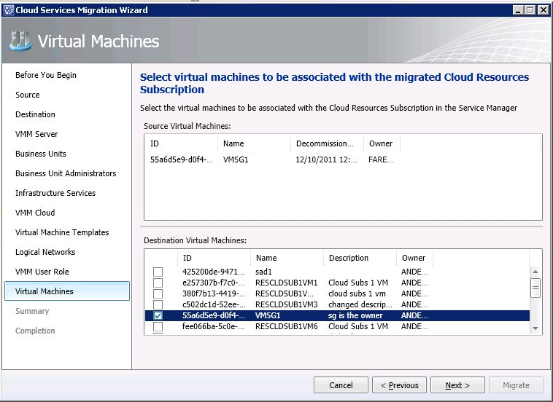
Figure 13. Virtual Machines

- On the Summary page, review the information and click Migrate.

- On the Completion page, click Close.

Post-Migration Tasks

Verify Migration
After you have migrated data you should verify that the migration has been successful.
To verify migration
- In the Service Manager console, click Configuration Items, click Cloud Services, click Tenants and then click Active Tenants.
- View the Active Tenants list.
- Select the migrated tenant from Active Tenants list and then click Edit.
- Verify that your data has been migrated.

Associate Virtual Machines with Cost Centers
Migrated virtual machines are not associated with cost centers. If you plan to use cost centers for billing or to run reports on virtual machines by cost center, then you may want to associate migrated virtual machines with cost centers.
To associate virtual machines with cost centers
- In the Service Manager console, click Configuration Items, click Cloud Services, click Virtual Machines and then click Active Virtual Machines.
- Select the virtual machine from the list of active virtual machines and then click Edit.
- On the General tab, type the cost center in the Cost Center box and click OK

