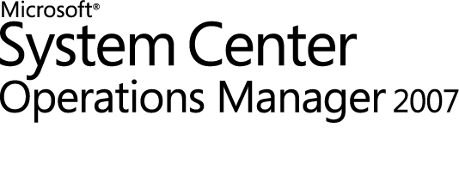

Microsoft Dynamics® AX 2009 Management Pack Guide for Operations Manager 2007
Microsoft Corporation
Published: May 2009
Send suggestions and comments about this document to mpgfeed@microsoft.com. Please include the management pack guide name with your feedback.
Copyright
Information in this document, including URL and other Internet Web site references, is subject to change without notice. Unless otherwise noted, the companies, organizations, products, domain names, e-mail addresses, logos, people, places, and events depicted in examples herein are fictitious. No association with any real company, organization, product, domain name, e-mail address, logo, person, place, or event is intended or should be inferred. Complying with all applicable copyright laws is the responsibility of the user. Without limiting the rights under copyright, no part of this document may be reproduced, stored in or introduced into a retrieval system, or transmitted in any form or by any means (electronic, mechanical, photocopying, recording, or otherwise), or for any purpose, without the express written permission of Microsoft Corporation.
Microsoft may have patents, patent applications, trademarks, copyrights, or other intellectual property rights covering subject matter in this document. Except as expressly provided in any written license agreement from Microsoft, the furnishing of this document does not give you any license to these patents, trademarks, copyrights, or other intellectual property.
© 2009 Microsoft Corporation. All rights reserved.
Microsoft, Microsoft Dynamics, Active Directory, Windows, and Windows Server are trademarks of the Microsoft group of companies.
All other trademarks are property of their respective owners.

Contents
Microsoft Dynamics AX 2009 Management Pack Guide 5
Document Version 5
Introduction 5
Getting the Latest Management Pack and Documentation 5
Supported Configurations 6
Getting Started 6
Before You Import the Management Pack 6
Files in This Management Pack 7
Recommended Additional Management Packs 7
How to Import the Microsoft Dynamics AX 2009 Management Pack 7
Create a New Management Pack for Customizations 8
Management Pack Rules 8
Security Considerations 9
Create a Run As Account 10
Associate the Run As Account with the Microsoft Dynamics AX profile 12
Understanding Management Pack Operations 14
Objects that the Management Pack Discovers 14
Classes 15
How the Health Model Rolls Up 16
Key Monitoring Scenarios 17
Management Pack Tasks 18
Reports 18
Troubleshooting 19
Error messages 19
Informational messages 27

Microsoft Dynamics AX 2009 Management Pack Guide
This guide explains how to use the Microsoft Dynamics® AX 2009 Management Pack for Microsoft® System Center Operations Manager 2007.
It includes a management pack overview and monitoring scenarios for the Microsoft Dynamics AX 2009 Management Pack. For more information about Operations Manager 2007, see the System Center Operations Manager Web site.
Document Version
The information in this guide is based on Release 1.0.0.50 of the Microsoft Dynamics AX 2009 Management Pack.
Revision History

Release Date | Changes
May 2009 | Version 1 of the document released

Introduction
Microsoft Dynamics AX is a comprehensive business management solution for mid-sized and larger organizations that works with other Microsoft software to improve productivity. Microsoft Dynamics AX is built to make it easy to do business across locations and countries by consolidating and standardizing processes, providing visibility across your organization, and helping to simplify compliance.
Monitoring Microsoft Dynamics AX with Operations Manager can reduce the cost of managing a distributed Microsoft Dynamics AX system. Operators and administrators can view information about all Application Object Server (AOS) instances in the environment, take AOS servers offline for maintenance and troubleshoot problems with AOS instances – all from a centralized console. In combination with the Management Packs for SQL Server and Windows Server, the Microsoft Dynamics AX 2009 Management Pack enables administrators to proactively react to changes in the overall health of the Microsoft Dynamics AX environment, and to adjust the system for optimal performance and reliability.
Getting the Latest Management Pack and Documentation
You can find the Microsoft Dynamics AX 2009 Management Pack in the System Center Operations Manager 2007 Catalog.
Supported Configurations
You must install the following software before you can use the Microsoft Dynamics AX 2009 Management Pack:
- Microsoft Dynamics AX 2009. We recommend installing the latest service packs and updates on all servers and agents. For more information about installing and initializing Microsoft Dynamics AX 2009, see the Microsoft Dynamics AX Installation Guide.
- The Operations Manager agent must be installed on all Microsoft Dynamics AX servers that are being monitored. The Microsoft Dynamics AX 2009 Management Pack does not support agentless monitoring. For more information about installing the agent, see Deploying Agents in Operations Manager 2007.
- System Center Operations Manager 2007 with Service Pack 1. The Microsoft Dynamics AX 2009 Management Pack depends on components that are installed as part of Operations Manager 2007 Service Pack 1.
Getting Started
This section describes the actions you should take before you import the management pack, any steps you should take after you import the management pack, and information about customizations.
Before You Import the Management Pack
Before you import the Microsoft Dynamics AX 2009 Management Pack, perform the following actions:
- Be sure that all core components for Microsoft Dynamics AX 2009 are installed, including the database, application files, Application Object Server (AOS), and client.
- Install the latest service packs and updates for Microsoft Dynamics AX 2009 (recommended, but not required).
- If you have an Oracle database server, and the AOS and the database are on different computers, make sure that MDAC (Microsoft Data Access Components) is installed on the AOS computer. MDAC allows the management pack to communicate with the Oracle server. You can download MDAC from the Microsoft Download Center.
- Be sure that the AOS instances that will be monitored via System Center Operations Manager start successfully.
- Complete all required initialization checklist steps by using the Microsoft Dynamics AX client.
Files in This Management Pack
To monitor Microsoft Dynamics AX, you must first download the Microsoft Dynamics AX 2009 Management Pack from the System Center Operations Manager 2007 Catalog. The Microsoft Dynamics AX 2009 Management Pack includes the following files:
- Microsoft.Dynamics.AX.Management.Pack.mp
- Microsoft Dynamics AX 2009 Operations Manager 2007 MP.doc
- EULA.rtf
- Readme.rtf
Recommended Additional Management Packs
To perform complete service-oriented monitoring of Microsoft Dynamics AX servers, you may want to download the following additional management packs from the System Center Operations Manager 2007 Catalog.

Management Pack name | Details
Microsoft SQL Server® Management Pack | Version : 6.0.6460.0  The SQL Server Management Pack provides discovery and monitoring capabilities for SQL Server 2000, 2005, and 2008 installations and components. Use this management pack to monitor the availability and performance of SQL Server.
Windows Server® Operating System Management Pack | Version: 6.0.6321.5  The Windows Server Operating System Management Pack provides the fundamental monitoring basics for computers running Windows 2000 Server, Windows Server 2003, and Windows Server 2008 operating systems.

How to Import the Microsoft Dynamics AX 2009 Management Pack
For instructions about importing a management pack, see How to Import a Management Pack in Operations Manager 2007.
Create a New Management Pack for Customizations
Most vendor management packs are sealed so that you cannot change any of the original settings in the management pack file. However, you can create customizations, such as overrides or new monitoring objects, and save them to a different management pack. By default, Operations Manager 2007 saves all customizations to the default management pack. As a best practice, you should create a separate management pack for each sealed management pack that you want to customize.
Creating a new management pack for storing overrides has the following advantages:
• It simplifies the process of exporting customizations that were created in your test and pre-production environments to your production environment. For example, instead of exporting a default management pack that contains customizations from multiple management packs, you can export just the management pack that contains customizations of a single management pack.
• You can delete the original management pack without first deleting the default management pack. A management pack that contains customizations is dependent on the original management pack. This dependency requires you to delete the management pack with customizations before you can delete the original management pack. If all of your customizations are saved to the default management pack, you must delete the default management pack before you can delete an original management pack.
• It is easier to track and update customizations to individual management packs.
For more information about sealed and unsealed management packs, see Management Pack Formats. For more information about management pack customizations and the default management pack, see About Management Packs in Operations Manager 2007.
Management Pack Rules
Management pack rules collect data from various sources, such as Perfmon, EventLog, SNMP, and log files. That data is then stored in the Operations Manager database or the data warehouse and can be used for reporting purposes. By default, the rules included in the Microsoft Dynamics AX 2009 Management Pack are enabled.
Adding more rules increases the value of the Management Pack. For information about how to create new rules, see How To Create a Rule in the Operations Manager 2007 Help. The following types of rules can be created:
- Event Rules – Event rules examine events that have occurred on managed servers. The agents retrieve the events and store them in the database. Logged information about errors and significant events from the monitored systems is displayed.
- Alert Rules – Alert rules examine the alerts generated by alert event rules to determine if a notification needs to be prepared. They are configured to trigger a notification when an alert with a severity level of “Critical Error” is generated.
- Performance-Based Rules – Performance-based rules retrieve performance data from monitored systems, and performance data is stored in the Operations Manager 2007 database
Security Considerations
Rules, tasks, monitors, and discoveries defined in a management pack require credentials to run on a targeted computer. By default, they run using the Operations Manager default action account.
To run rules, tasks, monitors, or discoveries using a different account, you must associate a Run As Account with the Run As Profile for the management pack. Tasks, rules, monitors, and discoveries are associated with a Run As Profile when a management pack is created. You should create a new account with the appropriate privileges and associate it with the Run As Profile.
When you import the Microsoft Dynamics AX 2009 Management Pack, a Run As Profile called Microsoft Dynamics AX 2009 User Account is installed. We recommend creating a Run As Account that is a member of the BUILTIN\Administrators group on each monitored computer. In addition, the account must have SELECT rights on the following tables in the Microsoft Dynamics AX 2009 database:
- sysclientsessions
- sysserversessions
- sysserverconfig
- userinfo
- batch
- batchjob

Note: If the Run As Account does not have the recommended permissions, you will not be able to view all of the data provided by the Microsoft Dynamics AX 2009 Management Pack.
For more information about Run As Accounts and Run As Profiles, see Run As Accounts and Run As Profiles in the Operations Manager 2007 Help.
Create a Run As Account
- In the Operations Console, open the Administration pane and expand the Security node.
- Right-click Run As Accounts and select Create Run As Account to launch the wizard.
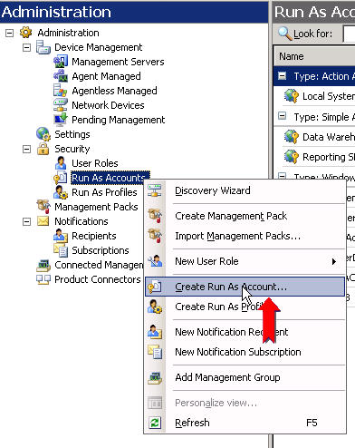
- The Introduction page is displayed. Click Next.
- The General page is displayed. Select the account type and provide a display name and description for the Run As Account. Then click Next.
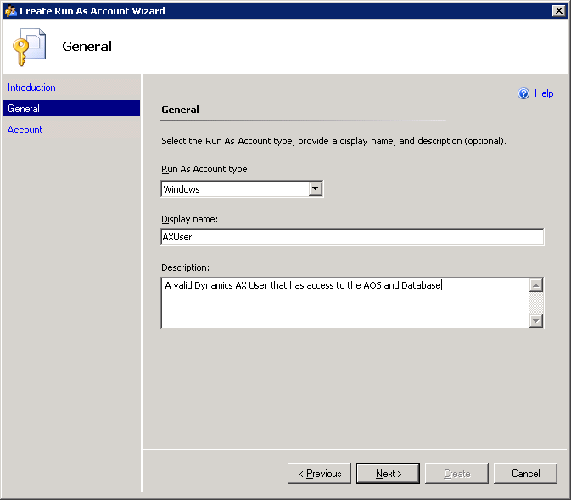
- The Account page is displayed. Enter the name, domain, and password for the Run As Account. Then click Create.
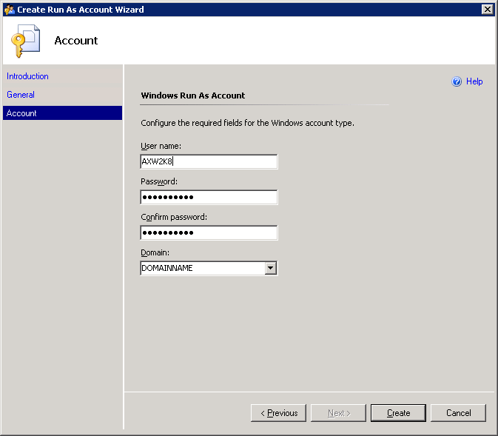
- The new account will be displayed in the Run As Account pane.
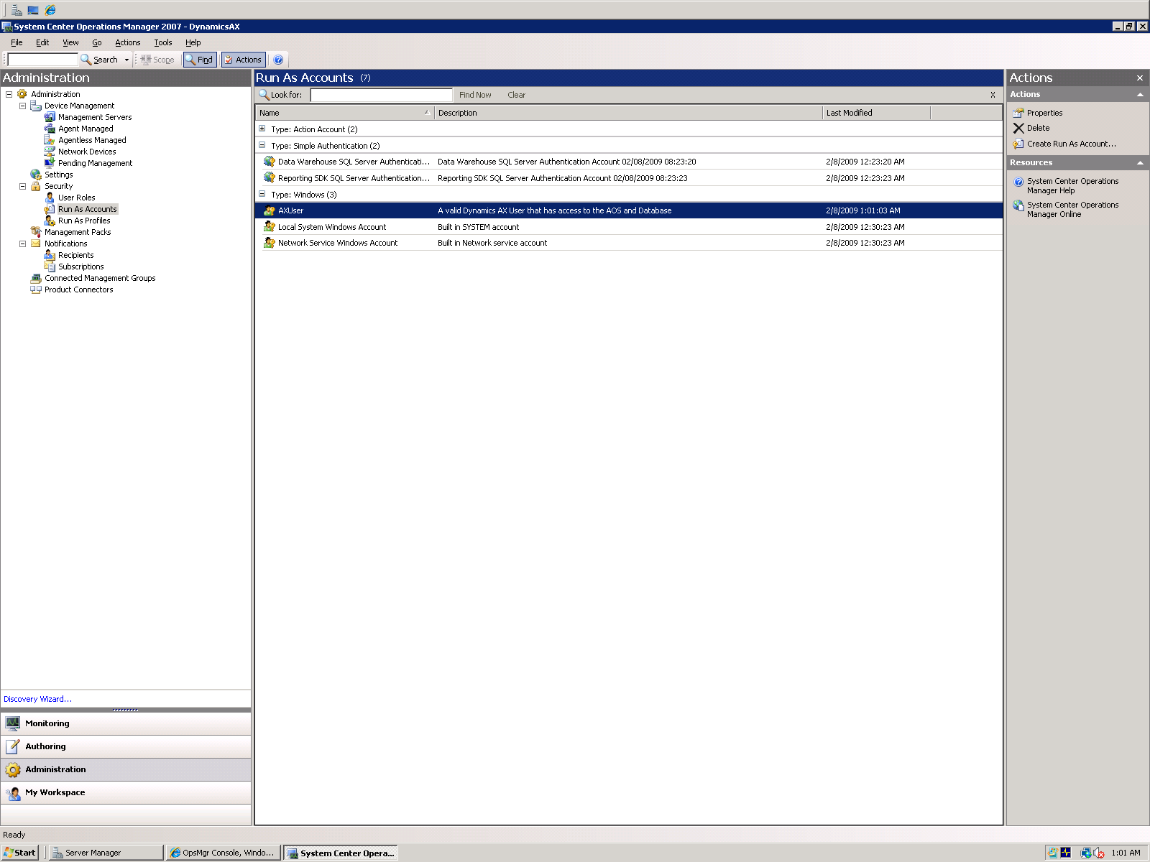
Associate the Run As Account with the Microsoft Dynamics AX profile
After you have created the Run As Account, you must associate the Run As Account with the Run As Profile for the Microsoft Dynamics AX 2009 Management Pack.
Note: The Microsoft Dynamics AX 2009 Management Pack must be installed in order to see the Run As Profile for Microsoft Dynamics AX.
- In the Operations Console, open the Administration pane and select the Run As Profiles node.
- Double-click Microsoft Dynamics AX 2009 User Account in the center pane. (If this account is not displayed in the list, right-click Run As Profiles and click Refresh.)
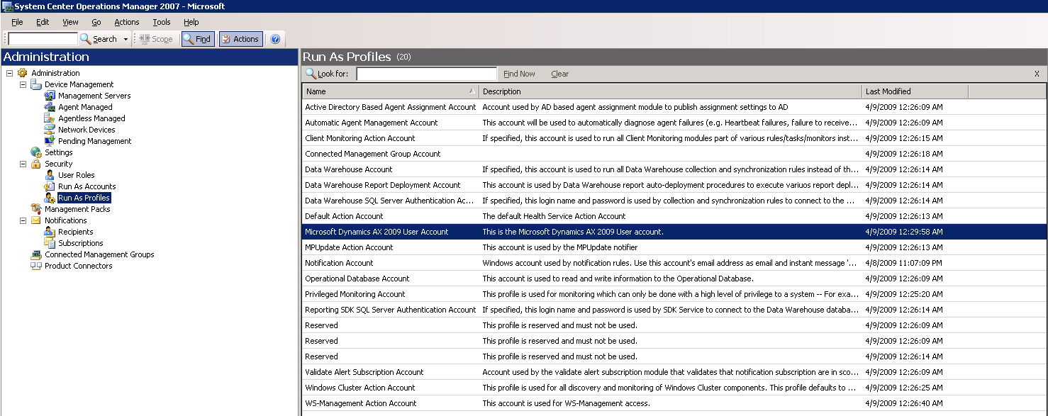
- To specify a Run As Account for a target computer, select the Run As Accounts tab.
You can associate a different Run As Account with each target computer. If no Run As Account is specified for a target computer, the default action account will be used.
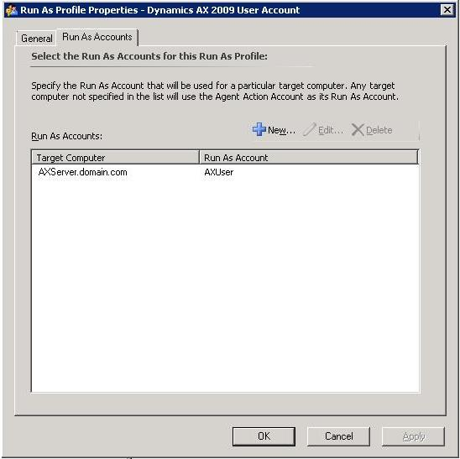
- Click New and select the account to associate with the target computer. Click OK.
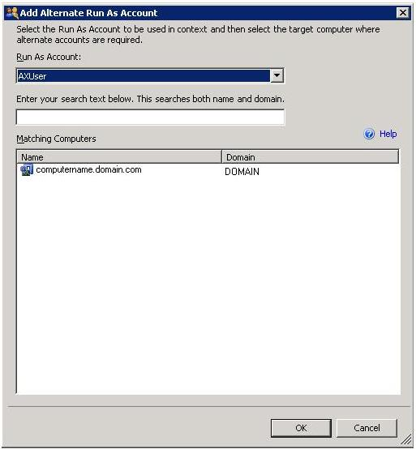
- Repeat step 4 for each target computer that will be monitored.
- When you are finished associating Run As Accounts with computers, click OK in the Run As Profiles window.
Understanding Management Pack Operations
The Microsoft Dynamics AX 2009 Management Pack discovers and monitors installed AOS instances without any additional configuration. The Management Pack provides data about system health, user sessions, and batch jobs for all instances of the AOS running on registered computers.
The monitoring scenarios enabled by the Management Pack include the following:
- View version information for each AOS in the environment
- View the number of active user sessions on an AOS before taking the AOS offline for maintenance
- View scheduled batch jobs and tasks
- Receive alerts when an AOS instance has stopped
- Troubleshoot problems by viewing event messages for monitored AOS instances
Objects that the Management Pack Discovers
The Microsoft Dynamics AX 2009 Management Pack discovers the object types described in the following table. For information about discovering objects, see Object Discoveries in Operations Manager 2007 in the Operations Manager 2007 Help.

Name | Purpose | Discovered Automatically
Microsoft Dynamics AX 2009 Computers Group Discovery | Detects computers where Microsoft Dynamics AX has been installed. | Yes
Microsoft Dynamics AX 2009 Computers Discovery | Groups the computers that have Microsoft Dynamics AX 2009 AOS instances on them. | Yes
Microsoft Dynamics AX 2009 AOS Discovery | Gathers information about Microsoft Dynamics AX 2009 AOS instances. | Yes

By default, the Microsoft Dynamics AX 2009 Computers Group discovery process runs every 12 hours and the Microsoft Dynamics AX 2009 AOS discovery process runs every 5 minutes. If you want to change these intervals, you can create customizations to override the values.
To override the time interval for running automatic discovery
1. In the Authoring pane, expand Management Pack Objects, and then click Object Discoveries.
2. On the Operations Manager toolbar, click Change Scope, and then filter the objects that appear in the details pane to include only Microsoft Dynamics objects.
3. In the Operations Manager toolbar, use the Scope button to filter the list of objects, and then select the object that you want to change the discovery interval for.
4. In the Actions pane, click Overrides, click Override the Object Discovery, and then select whether you want to override the discovery interval for all objects or for a specific object.
5. In the Override Properties dialog box, click the box for the Interval in seconds parameter and specify a new value for the Override Setting.
6. Under Management Pack, click New to create an unsealed version of the management pack, and then click OK, or select an unsealed management pack that you previously created in which to save this override. As a best practice, you should not save overrides to the Default Management Pack.
For more information about customizing a management pack, see the "Create a New Management Pack for Customizations" section in this document.
Classes
The Service Model for the Microsoft Dynamics AX 2009 Management Pack consists of classes that represent Microsoft Dynamics AX objects. System Center Operations Manager uses these classes to discover, detect the health of, and actively monitor each Microsoft Dynamics AX AOS. The Service Model consists of the following classes:
- Dynamics Server Group
- Dynamics Servers
- Instance
- User
- Job
- Batch
The following diagram represents the classes and their relationships.
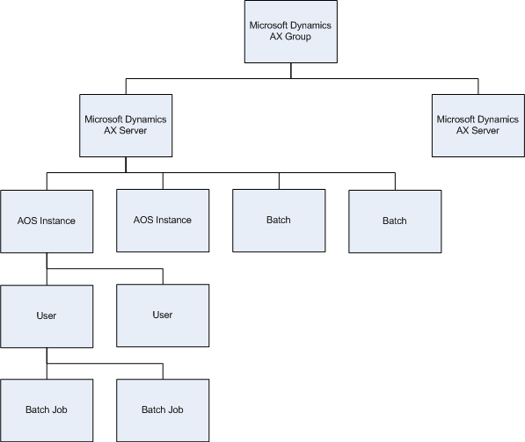
How the Health Model Rolls Up
The health model for the Microsoft Dynamics AX 2009 Management Pack is a dynamic view of the state of each AOS, connected users, and batch jobs and tasks. The health model reflects the current state of the object instance and is constantly updated by the monitors that run in the background.
The health model also shows the containment relationships of the service model, which allows you to drill down into the health of a contained object. The health status of a Microsoft Dynamics AX class depends on the health status of its sub-components. For example, health status is rolled up from the instance level to the server. This means that if more than one AOS is installed on a single computer, and if a single AOS experiences a change in health, the Operations Console will show that a change has occurred on both the AOS instance and the computer. To view the relationship hierarchy, see the “Classes” section of this document.
To view the health model of any object, right-click the object in the center pane and then click Open > Health Explorer.
Key Monitoring Scenarios
Use the Microsoft Dynamics AX 2009 Management Pack to monitor the following information about the AOS instances in your environment.
Alerts
This view displays alerts generated by the management pack. For example, when an AOS instance stops running, the Health State of the AOS instance changes from “Healthy” to “Warning” and an alert is generated.
Note: To avoid generating alerts, we recommend placing AOS instances in maintenance mode during planned outages. In maintenance mode, alerts, notifications, rules, monitors, automatic responses, state changes, and new alerts are suppressed. For general instructions about placing a monitored object in maintenance mode, see How to Put a Monitored Object into Maintenance Mode in the Operations Manager 2007 Help.
Batch Jobs
This view displays batch jobs that were created by users. You can view batch jobs that are on hold, are currently running, have failed with an error, are in the process of being canceled, or have been canceled. View details such as job ID, job status, scheduled start date and time, actual start date and time, creator, and associated company.
Note: Batch jobs are displayed only when the user who created the job is currently connected to an AOS instance. If the user is connected to multiple AOS instances, batch jobs associated with that user will be displayed multiple times.
Batch Tasks
This view displays batch tasks that run on the AOS instances in the environment. You can view batch tasks that are on hold, are currently running, have failed with an error, are in the process of being canceled, or have been canceled. View details such as task ID, run type (client or server), start date and time, associated company, and the name of the AOS instance where the task runs.
Application Object Server Computers
This view displays a list of all computers that AOS instances are detected on, and the health of those computers.
Application Object Servers
This view displays information about individual AOS instances. You can view configuration information such as database server details, AOS version information, and computer name. You can monitor the start date and time, status, and number of active client sessions for an AOS instance. You can also verify whether an AOS instance is used as a batch server, and view the maximum number of batch threads allowed on that server.
Events
This view displays Event Log messages associated with monitored AOS instances. For more information about Event Log messages for Microsoft Dynamics AX, see the “Troubleshooting” section of this document.
Users
This view displays the users currently connected to AOS instances. For each user session, you can view information such as Microsoft Dynamics AX user name, Active Directory domain name and user ID, session type (User, Business Connector, Worker, or Web User), session state, login date and time, and security identifier (SID).
Note: Date and time information is displayed in Coordinated Universal Time (UTC) in the Users view. (UTC is the standard time common to every place in the world, coordinated by the International Bureau of Weights and Measures. It is also known as Greenwich Mean Time.)
Management Pack Tasks
The Microsoft Dynamics AX 2009 Management Pack allows you to perform the following tasks from the Actions menu in the Operations Console.
Note: These tasks are run locally on the monitored computer by the Operations Manager agent. The tasks do not run on the Operations Manager server.

Task | Description
Stop Application Object Server | Stop an AOS instance for maintenance.  Note: To avoid generating alerts, we recommend placing AOS instances in maintenance mode during planned outages. In maintenance mode, alerts, notifications, rules, monitors, automatic responses, state changes, and new alerts are suppressed. For general instructions about placing a monitored object in maintenance mode, see How to Put a Monitored Object into Maintenance Mode in the Operations Manager 2007 Help.
Start Application Object Server | Restart an AOS instance that has stopped running.

Reports
This version of the Microsoft Dynamics AX 2009 Management Pack does not include any reports. For information about creating your own reports from Operations Manager, see Creating Reports in the Operations Manager 2007 Help.
Troubleshooting
The following tables list the possible event log messages for the Microsoft Dynamics AX AOS.
Error messages
The following table contains error messages, and it includes the recommended user action to remedy each error.
ID | Message text | Description | Action
103 | Microsoft Dynamics AX 2009 – The control handler not installed | The Microsoft Dynamics AX Server Manager could not initialize the control handler. Can be caused by failed system setup. The registration of the AOS in the registry might be missing or is not valid. | Recover a registry backup or reinstall the AOS.
104 | Microsoft Dynamics AX 2009 – Initialization process failed | The Microsoft Dynamics AX Server Manager could not complete the initialization process. Can be caused by resource shortage. | Verify that system resources are at an acceptable level for the AOS Windows service to run.
106 | Microsoft Dynamics AX 2009 – Bad request | The Microsoft Dynamics AX Server Manager has received an unsupported control request. | Use the Server Manager control panel to control the Server Manager and each AOS.
107 | Microsoft Dynamics AX 2009 – Debug information: %2 | This event is used to issue debug information from Microsoft Dynamics AX. | Debug events are used for tracking the source of other events, so no general action can be specified.
113 | Microsoft Dynamics AX 2009 – Attempt to delete print window in non-server mode | Tracing event for internal Microsoft Dynamics AX error. | If this error is connected to a given action and is reproducible, report it as an error.
115 | Microsoft Dynamics AX 2009 – Attempt to print in non-server mode | Tracing event for internal Microsoft Dynamics AX error. | If this error is connected to a given action and is reproducible, report it as an error.
116 | Microsoft Dynamics AX 2009 – Attempting to call pause in non-server mode | Tracing event for Microsoft Dynamics AX error. System method pause() used inappropriately within X++ code. | Avoid using the Pause() method or limit it to client-only code.
117 | Microsoft Dynamics AX 2009 – Database error | Database error has occurred. The message body will specify the error message and the session/User ID causing the error. | Check the database server for additional errors or correct the code causing it.
118 | Microsoft Dynamics AX 2009 – WinSock initialization error | AOS Performance Monitor Counters could not establish a connection to the server manager. | Start the AX Server Manager using the Windows Control Panel.
119 | Microsoft Dynamics AX 2009 – Establishing computer name failed | AOS Performance Monitor Counters could not establish the name of the computer. | Check the network setup of the local computer and verify the server name.
120 | Microsoft Dynamics AX 2009 – Establishing DNS name of the computer failed | AOS Performance Monitor Counters could not establish the DNS name of the local computer. | Check the network setup of the local computer and verify the server name.
121 | Microsoft Dynamics AX 2009 – Connection to Server Manager could not be established | AOS Performance Monitor Counters could not connect to the Server Manager. | Start the Server Manager using the Windows Control Panel if it is not running. To correct an incorrect port, add the AOCP/TCP entry to the ETC/SERVICES file, and then restart both Server Manager and Performance Monitor.
122 | Microsoft Dynamics AX 2009 – Socket could not be created | AOS Performance Monitor Counters could not create the needed socket. | Check the network setup of the local computer and verify that resources are sufficient for Windows Sockets to work.
123 | Microsoft Dynamics AX 2009 – Registry entry could not be opened | AOS Performance Monitor Counters could not open the registry keys describing the performance counters for Microsoft Dynamics AX. | Verify that performance counters work. If they do, check the registry key for SYSTEM\CurrentControlSet\Services\Axapta Object Server\Performance or "SYSTEM\\CurrentControlSet\\Services\\Axapta COM Connector\\Performance". If they are present, be sure that the AOS account has full privileges to these keys. If they are not present, recover a registry backup or reinstall the AOS.
124 | Microsoft Dynamics AX 2009 – Failed to open First Counter for Performance Monitor | AOS Performance Monitor Counters could not locate needed registry entry. | Recover a registry backup or reinstall the AOS to correctly initialize the registry.
125 | Microsoft Dynamics AX 2009 – Failed to open First Help for Performance Monitor | AOS Performance Monitor Counters could not locate needed registry entry | Recover a registry backup or reinstall the AOS to correctly initialize the registry.
126 | Microsoft Dynamics AX 2009 – Cannot connect to Server Manager | AOS could not connect to the local Microsoft Dynamics AX Server Manager and identify it. | Start the Server Manager using the Windows Control Panel.
127 | Microsoft Dynamics AX 2009 – Error in server thread for user | The session for the specified user has been terminated due to an exception. | Check the AOS event log for surrounding events and react according to those events.
128 | Microsoft Dynamics AX 2009 – Error in server thread | A session on the server has been shut down due to an exception. It was not possible to establish which user owned the session. | Check the AOS event log for surrounding events and react according to those events.
131 | Microsoft Dynamics AX 2009 – Failed to stop Application Object Server | The AOS did not stop upon the request from the Server Manager. | The Server Manager is not allowed to end the process. This can occur when the AOS is not started from the Server Manager. This results in different security contexts that will not allow the Server Manager to stop the AOS.
132 | Microsoft Dynamics AX 2009 – Server Manager could not be started | The Server Manager could not correctly be initialized, and therefore, cannot run. | Check the event log for other events describing the situation and react according to those events.
135 | Microsoft Dynamics AX 2009 – User disconnected during startup | A user was disconnected by the AOS prior to successfully logging in. | This normally indicates a client problem.
136 | Microsoft Dynamics AX 2009 – User disconnected abnormally | A user disconnected without signing out correctly. | This normally indicates a client problem.
137 | Microsoft Dynamics AX 2009 – User disconnected abnormally during startup | A user disconnected while still not correctly identified. | This normally indicates a client problem.
138 | Microsoft Dynamics AX 2009 – Application Object Server stopped | The Server Manager successfully launched the named AOS. | The AOS will be completely operational after the EVMSG_AOSREADY (149) message appears.
139 | Microsoft Dynamics AX 2009 – Failed to initialize Message System | The kernel message system could not be correctly initialized so the AOS cannot be started. | Be sure that the file mentioned in the body of the event is available, and that. sufficient access rights are granted so that the file can be processed.
140 | Microsoft Dynamics AX 2009 – Database login failed | The AOS could not log in to the database. | This event contains the error message issued by the database server when Microsoft Dynamics AX tried to log in. The event log will also contain an event EVMSG_SQL_DIAGNOSTICS (163) that specifies the parameters used to establish the connection. Review these and correct the Microsoft Dynamics AX configuration, ODBC setup or database security.
141 | Microsoft Dynamics AX 2009 – Reindexing is in progress | The Microsoft Dynamics AX process is reindexing one of the needed files. | This event will be followed by the event EVMSG_UTIL_REINDEX_DONE (146) stating that this reindexing operation is done. The time elapsed between these two events could indicate disk inefficiencies.
142 | Microsoft Dynamics AX 2009 – Directory not found | The specified directory could not be found. | Verify that the AOS configuration specifies the correct Microsoft Dynamics AX system directory and that the AOS user account can access this path. Note: Drive letters cannot be used by an AOS configuration to access network resources.
143 | Microsoft Dynamics AX 2009 – Required directory not found | The specified system directory does not contain required subdirectory. | Verify that the AOS configuration specifies the correct Microsoft Dynamics AX system directory and that the directory stated in the body of the event is present and accessible.
144 | Microsoft Dynamics AX 2009 – Error accessing registry | An operation accessing the system registry failed. | This event could indicate a missing or failed installation of Microsoft Dynamics AX. Access rights might be assigned incorrectly in the registry.
146 | Microsoft Dynamics AX 2009 – Reindexing completed | The Microsoft Dynamics AX process finished reindexing one of the needed files. | This event will follow the event EVMSG_UTIL_REINDEX (141) stating that this reindexing operation started.
147 | Microsoft Dynamics AX 2009 – Client connection closed | The connection to the Microsoft Dynamics AX client was disrupted during a communication process. | This is normally caused by disrupted network services or client connectivity problems. If the problem occurs for multiple clients, check server connectivity.
148 | Microsoft Dynamics AX 2009 – Client login validation failed | The Windows security system rejected the logon for the client user. | If domain authentication is required for client users, validate that the client computer is correctly logged on to the Windows domain.
149 | Microsoft Dynamics AX 2009 – AOS is in ready state | The AOS is fully initialized and ready to service clients. | Contains information about the configuration of the environment.
150 | Microsoft Dynamics AX 2009 – Thread created. | This event is issued as a tracing mechanism for which thread is allocated to which session. | This event is used as a supplement to other events when tracing session or thread specific problems.
151 | Microsoft Dynamics AX 2009 – Internal AOCP revision mismatch | The AOS received a request for service from an incorrect client version. | Indicates a version mismatch between the client and the server. The client might be running a different version or service pack level. The client might have contacted the incorrect server. Update the client software version or change the client configuration.
152 | Microsoft Dynamics AX 2009 – I/O error | Microsoft Dynamics AX experienced a low level or logical file error. | This event indicates the name of the file, error and cause. File errors are usually caused by malfunctioning hardware. Try locating the files on a different drive and if the error persists, restore a backup.
153 | Microsoft Dynamics AX 2009 – Forcing termination through the Server Manager | The AOS instance did not shut down within a reasonable amount of time so the Server Manager forced the process to shut down. | Check the event log for probable causes.
154 | Microsoft Dynamics AX 2009 – Shutting down due to idle timeout | The AOS instance shut down after being idle for the configured interval. | To change this behavior, change shutdown settings on the Server tab of the instance settings.
164 | Microsoft Dynamics AX 2009 – Call attempt without client connection | The session on the AOS tried to issue a call to a client-bound method without having a client available. | When coding clientless functionality, client-bound calls must be prohibited. This is only available within the Microsoft Dynamics AX Benchmark Tool.
165 | Microsoft Dynamics AX 2009 – Security failure | An error occurred while trying to authenticate computers and/or users. The event body contains information about the kind of error, the type, the severity, and the operation within which the error occurred. | Most security errors occur when the client and the server are not under sufficient domain control. If the AOS is servicing clients from outside its own domain, validation errors will occur. Verify AOS settings controlling the use of Windows Authentication, the validity of the domain setup and availability of domain controllers.
167 | Microsoft Dynamics AX 2009 – Active Directory integration failed | The AOS failed to publish itself to Active Directory. | Check Active Directory setup and access rights according to the error message included in the event body.
168 | Microsoft Dynamics AX 2009 – Failed to create a file | Microsoft Dynamics AX failed to create a file. | Check the availability of the directory contained in the event body.
170 | Microsoft Dynamics AX 2009 – Administrative connect from remote host rejected. | The Microsoft Dynamics AX Server Manager on the computer is configured to reject administrative connection requests from remote computers. | This is used to improve security in ASP setups and is documented as part of the ASP setup instructions.
171 | Microsoft Dynamics AX 2009 – Client did not complete connection in a timely manner | Reports problem connecting a client due to missing response from client. This can be caused by network problems, interrupted startup of a client or wrong type of client software. This event will occur when a non-Microsoft Dynamics AX 2009 client tries to connect to the AOS connection point. This will be the case for port-pollers and other software used to interrogate networks which could be signs of hostile attacks on the system. | Use the address of the client to validate and troubleshoot connection problems.
173 | Microsoft Dynamics AX 2009 – Unexpected failure | Issued as the consequence of an unrecoverable exception in the client session. Event log will include other messages that describe the exception. | Investigate surrounding events in the event log and the concurrent entries in the IIS log to establish a possible cause.
174 | Microsoft Dynamics AX 2009 – No license code is present | Issued when Microsoft Dynamics AX recognizes that it is running against a database backend for which no license code is present in the Microsoft Dynamics AX license. | Enter the correct license code for the database.
175 | Microsoft Dynamics AX 2009 – License error | Issued in relation to Microsoft Dynamics AX license verification difficulties. Problems reported as license errors will prevent the system from starting. | Review the content of the event body to determine proper action. In most cases, you must either change the configuration or enter correct license codes.
176 | Microsoft Dynamics AX 2009 – Diagnostics information | This event is issued by Microsoft Dynamics AX for diagnostics. | Content should be provided to Microsoft upon request.
178 | Microsoft Dynamics AX 2009 – Performance information | This event is issued by Microsoft Dynamics AX for performance diagnostics. | Indicates that an event might affect system performance. If this event occurs regularly, the performance of the system should be assessed.
179 | Microsoft Dynamics AX 2009 – Microsoft Dynamics AX 2009 fatal error | Microsoft Dynamics AX encountered a fatal (non-recoverable) error. | The system will stop. The AOS will restart automatically. Review the event log for preceding events to help determine the cause.
180 | Microsoft Dynamics AX 2009 – Protocol error in RPC | Protocol error detected in RPC. | Either the network transport has corrupted the package in a non-detectable way or the package was not valid when it left the other tier.  Network problems can also result in a significant loss of connection. Identify whether the problem occurs randomly or in relation to specific operations.
181 | Microsoft Dynamics AX 2009 – RPC Connection error | Error detected on the network connection to the Microsoft Dynamics AX client. | Connection errors are usually caused by either client disruption (crash, shutdown, etc.) or by network connectivity failures. Recurring connection errors indicate that you may need to adjust TCP parameters for the client.

Informational messages
The messages in the following table are informational only. They do not require user action.

ID | Message text | Description
105 | Microsoft Dynamics AX 2009 – Server Manager has started | The Microsoft Dynamics AX Server Manager has started.
108 | Microsoft Dynamics AX 2009 – Server stopped | The Microsoft Dynamics AX Application Object Server has stopped.
110 | Microsoft Dynamics AX 2009 – Trace message | General event message used for tracing cause for other events.
129 | Microsoft Dynamics AX 2009 – Application Object Server connected | An AOS started and was successfully connected to the Server Manager.
130 | Microsoft Dynamics AX 2009 – Starting Application Object Server | The Server Manager has begun startup of the named AOS.
133 | Microsoft Dynamics AX 2009 – User connected | A user was successfully connected to the AOS. The event specifies the user ID, session number and the assigned thread.
134 | Microsoft Dynamics AX 2009 – User disconnected | A user was disconnected from the AOS. The event specifies the user ID, session number and the assigned thread.
163 | Microsoft Dynamics AX 2009 – SQL diagnostics message | This event provides diagnostics information for the Microsoft Dynamics AX SQL engine.
166 | Microsoft Dynamics AX 2009 – Active Directory publishing succeeded | The AOS successfully published itself to Active Directory.
169 | Microsoft Dynamics AX 2009 – System information dump | This event contains dump information that describes the state of the system. It is used for tracing and diagnostics purposes.
172 | Microsoft Dynamics AX 2009 – Business Connector started | Issued by Business Connector when started. Shows details about the created context, process, etc.
182 | Microsoft Dynamics AX 2009 – Session manager error | Error detected while creating user session.
183 | Microsoft Dynamics AX 2009 – Update conflict detected | Update conflict detected when optimistic concurrency control is enabled.
184 | Microsoft Dynamics AX 2009 – Operating system is not supported | The AOS is running on an unsupported operating system.

